Learning to Automatically Generate Accurate ECG Captions

https://proceedings.mlr.press/v172/bartels22a/bartels22a.pdf

Key idea: Co-attention to make it more specific to ECGs caption
Although our problem bears similarity to image captioning, we argue there is a distinction which we aim to leverage to improve viability of the generated ECG captions. Whereas in image captioning the goal is to generate free textual descriptions for images in a wide variety of settings, our work only aims to generate clinically accurate textual descriptions of ECGs.
An accurate ECG description contains information on a number of characteristics of the input signal. Intuitively, this greatly restricts the range of plausible realistic textual descriptions that may be associated to any single ECG. We assume that embedding such information specific to this problem into our model may greatly improve the generated ECG descriptions.

This model has an intermediate classification step, by using a simple classification layer on the encoded ECG representation. This classification step yields the labels, which are encoded with a learnable embedding layer. The addition of the classification step adds an extra term to the objective function shown in Equation 3.
λ1 = 0.7, λ2 = 0.3
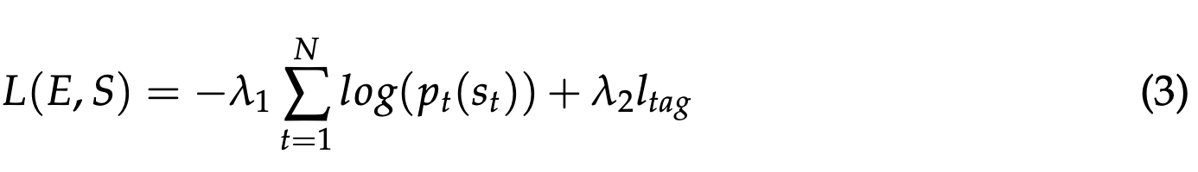

How to compute l_tag?

How to do “Qualitative evaluation”: A method I liked

In the qualitative experiment, two cardiologists, working in the cardiology outpatient clinic, were asked to evaluate ECG descriptions. They evaluated 30 ECGs randomly selected from the test set. Each of these ECGs were interpreted by a expert, the PKEL model trained on the physician-annotated dataset, the PKEL model trained on the physician corrected dataset, and the rule-based system. The ECG-description pairs were shown in a random order to prevent bias. Experts rated the description with the following labels:
1) good, 2) small adjustments needed, 3) large adjustments needed, and 4) unusable. Results, visualised in figure Figure 2, show that the PKEL model outperforms the rule-based approach in the qualitative evaluation. The cardiologist interpretations are superior to our model. The cardiologist interpretations are good in only 61% of the cases, showing a large inter observer variance
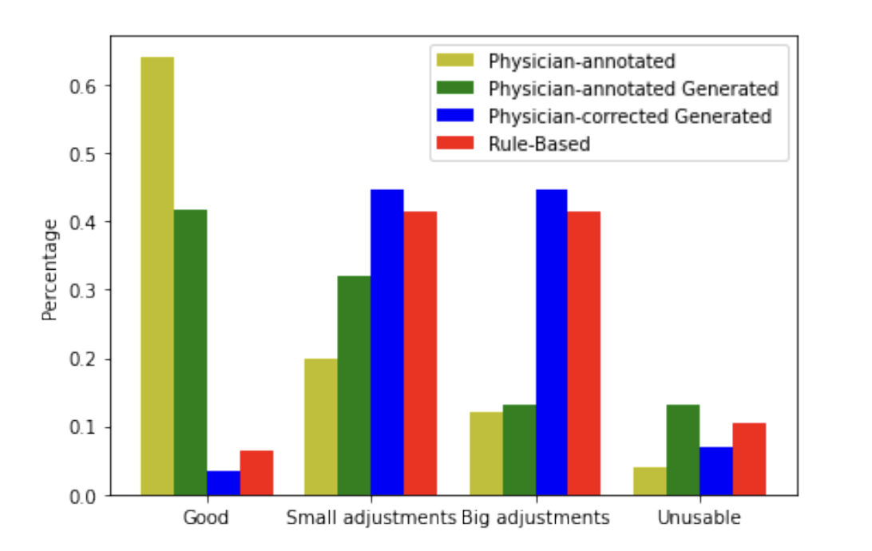

Old paper (2018) that introduced the idea of co-attention:

On the Automatic Generation of Medical Imaging Reports

CMU Researcher, 2018:
https://aclanthology.org/P18-1240.pdf

At decoding step $s$, the co-attention function is:
$$\text{ctx}(s)=f_{\text{coatt}}(\{v_{n}\}_{n=1}^{N}, \{a_{m}\}_{m=1}^{M}, h_{\text{sent}}^{(s-1)})$$

Inputs
- $v_{n}∈R^{D}$
Visual (or signal) features.
In ECG captioning, these correspond to ECG feature vectors instead of image regions.
- $a_{m}∈R^{E}$
Semantic tag embeddings.
These are embeddings of predicted labels or tags.
- $h_{\text{sent}}^{(s-1)}∈R^{H}$
Hidden state of the sentence LSTM at the previous time step.

Visual attention
$$α_{v,n}∝exp⁡(W_{v,\text{att}}tanh⁡(W_{v}v_{n}+W_{v,h}h_{\text{sent}}^{(s-1)}))$$
Semantic (tag / label) attention:
$$α_{a,m}∝exp⁡(W_{a,\text{att}}tanh⁡(W_{a}a_{m}+W_{a,h}h_{\text{sent}}^{(s-1)}))$$
The co-attention mechanism computes two attention distributions conditioned on the language state, one over ECG features and one over semantic labels, then fuses them into a single context vector used to guide word generation.

